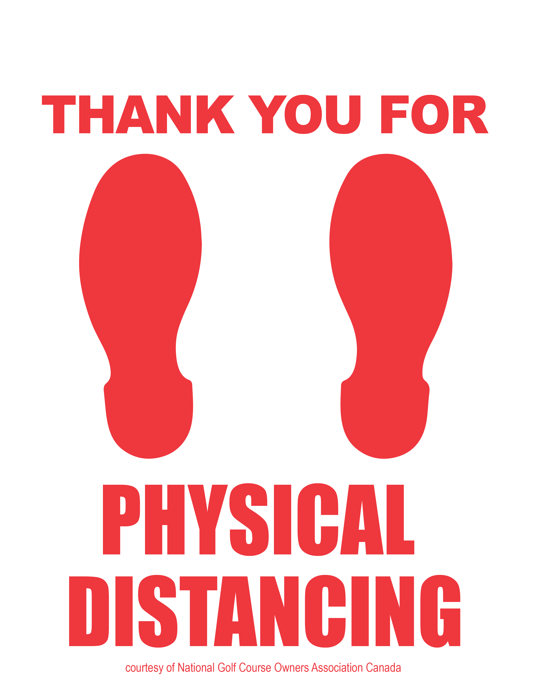

2 metres

**6 feet**

**INSERT YOUR LOGO HERE**