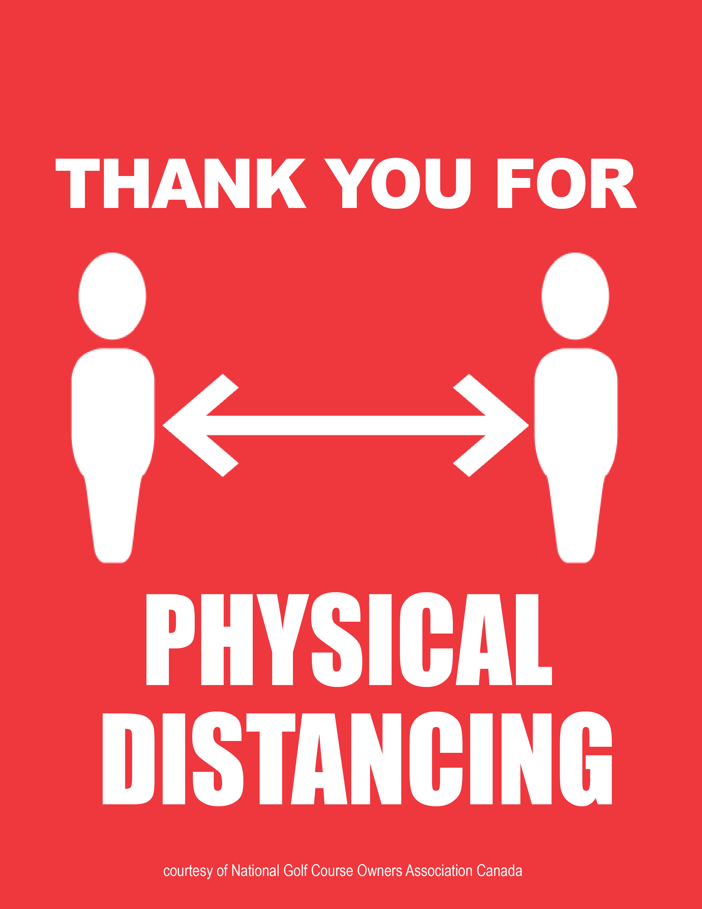

**2 METRES**

**COVID-19**

**INSERT YOUR LOGO HERE**